Work - 04
CLASS 09 - SCIENCE

 | Section A
1 | State True or False:  - Thetimetakenforonecompleteoscillationin the density(orpressure)ofthemediumiscalledthe time period (T) of the wave.  - Theportionofthemediumwheredensity(orpressure)hasavaluelargerthanitsaveragevalueis called a trough.  - Frequency (ν) and time period (T) are related as$\frac{1}{T}$ .  - A vibrating object produces a series of compressions and rarefactions in the medium.  - Sound waves cantravel through a vacuum but light waves and radio waves cannot travel through a vacuum.  - Multiple reflections of sound are used in megaphones, horns, musical instruments, and stethoscopes.  - As sound propagates, it is the sound energy that travels in the medium and not the particles of the medium.  - The change in density (or pressure) from the maximum value to the minimum value and again to the maximum value is called amplitude.  - Sound propagates in the medium as a series of compressions and rarefactions.  - SONARstandsfor SoundNavigation And Ranging.  - The speed of sound is the distance traveled by the sound wave per unit time.  - The laws of reflection for sound are the same as those for light.  - The sound of a drum is produced by the vibrations of the skin or its membrane when plucked.  - Rarefaction is the region of high pressure and rarefaction is the region of low pressure.  - The amplitude of a wave is the same as the amplitude of the vibrating body producing the wave.  - Pitch is the physiological sensation that helps in distinguishing a shrill sound from a flat sound.  - Whentheprongs of atuningfork move forward,compressionisformed,andwhen the prongs move backwards, rarefaction is formed.  - A sound of a single frequency is called a note.  - When a vibrating object moves forward, it pushes and compresses the air in front of it creating a region of high pressure.  - Thenumberofcompleteoscillationspersecondiscalledthe wavelengthofthesoundwave. | [20]
 | Section B
2 | Fill in the blanks:  - The distance between two consecutive compressions or two consecutive rarefactions is called ________of the wave.  - The magnitude of maximum disturbance in the medium on either side of the mean position is called the ________.  - ________ is determined by the wave form of the sound.  - The phenomenon of persistence or prolongation of audible sound after the source has stopped emitting it is called ________.  - ________ is a form of mechanical energy which produces the sensation of hearing.  - ________ is determined by the frequency of the wave.  - The sound produced by a mixture of several frequencies is called a ________.  - The repetition of sound caused by the reflection of sound waves from an obstacle is known as a/an ________.  - The matter or substance through which sound is transmitted is called a ________.  - The speed of sound ________ with the increase in temperature.  - ________ means a kind of rapid to and fro motion of an object.  - ________ finds applications in industry, medical science, and communication.  - The disturbance which moves through a medium when the particles of the medium set the neighboring particles into motion is known as a ________.  - ________ is the most common medium through which sound travels.  - The change in density (or pressure) from the maximum value to the minimum value and again to the maximum value is called a/an ________.  - Pitch is the ________ sensation which helps in distinguishing a shrill sound from a flat sound.  - ________ is determined by the amplitude of the wave. | [17]
 | Section C
3 | The echo - receiver of a sonar attached to a ship receives the echo from the bottom of sea 4 seconds after the ultrasonic waves were sent into the sea. 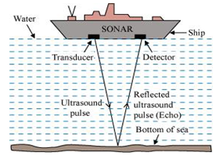  If the speed of sound in water is 1500 m/s, then what is the depth of the sea?  a) 15000 m  b) 6000 m  c) 3500 m  d) 3000 m | [1]
4 | Four students after conducting an experiment on reflection of sound marked the angle of incidence, angle of reflection as follows. Which one is correct? 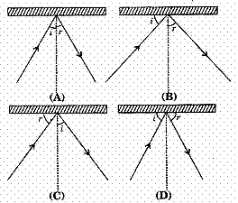  a) B  b) D  c) C  d) A | [1]
5 | Which part of Sonar converts the ultrasonic waves into electrical signals? 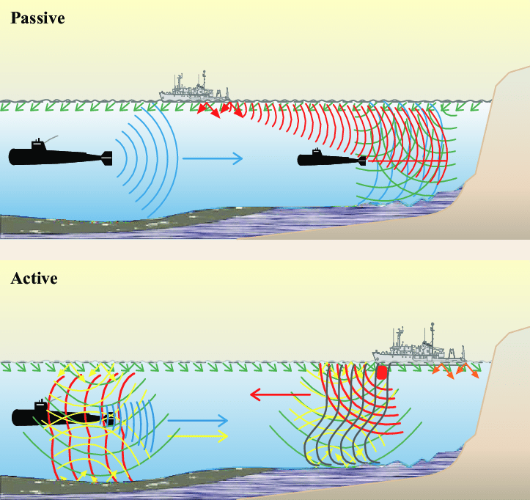  a) Detector  b) Transmitter  c) Boat  d) None of these | [1]
6 | Which characteristic of sound is represented in the given image? 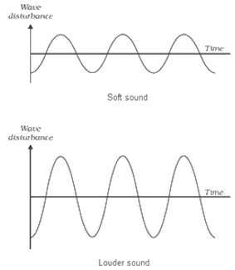  a) Quality  b) Amplitude  c) Pitch  d) Wavelength | [1]
7 | To verify the law of reflection of sound, the set - up of the arrangement needed is the one shown in figure: 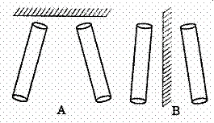  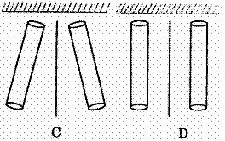  a) C  b) B  c) D  d) A | [1]
8 | When a pulse produced in a string moves through it and strikes a rigid pole, it is reflected back and the space of the reflected pulse resembles the shape given is 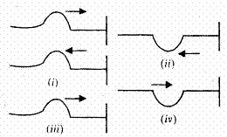  a) (iii)  b) (i)  c) (ii)  d) (iv) | [1]
9 | Four students after conducting an experiment on reflection of sound marked and angle of incidence, angle of reflection as follows which one is correct: 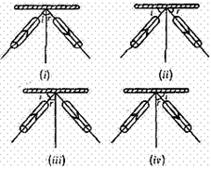  a) (iv)  b) (i)  c) (ii)  d) (iii) | [1]
10 | The given image shows the phenomena of: 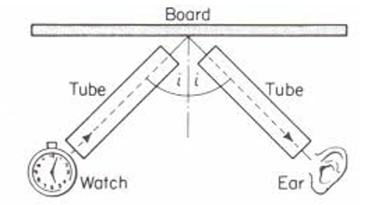  a) Reverberation  b) Echo  c) Reflection of sound  d) Multiple reflection | [1]
11 | A slinky, 5 m long, is tied to the hook in a wall and its other end is held tightly. It is then pulled as shown, and released suddenly. 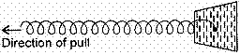  The disturbance created on the slinky are :  a) Longitudinal waves  b) Transverse pulse  c) Transverse waves  d) Longitudinal pulse | [1]
12 | The sound of heartbeats reaches the doctor’s ears from stethoscope by 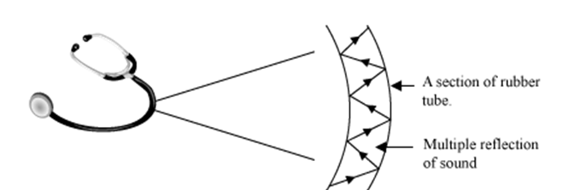  a) Multiple reflection  b) Reverberation  c) Reflection of sound  d) Echo | [1]
13 | A student sets up a slinky on a smooth table top in the manner shown here. He can produce a pulse in the slinky by giving a jerk to its free end: 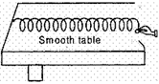  a) backward and forward along the length of the slinky  b) at an angle of 45 with the table top  c) towards left  d) downwards | [1]
14 | Soundboard work on the principle of: 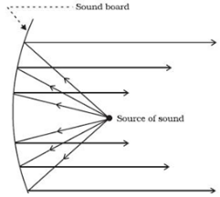  a) Reverberation  b) Echo  c) Multiple reflection  d) Reflection of sound | [1]
15 | What is the use of the device shown in the given below image?   a) All of these  b) The direction of underwater objects  c) The speed of underwater objects  d) The distance of underwater objects | [1]
16 | What is velocity of pulse for the slinky indicated in the figure below: 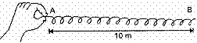  Given that the pulse took 5 seconds to travel from A to B and then back to A.  a) 5 m/s  b) 4 m/s  c) 8 m/s  d) 10 m/s | [1]
17 | Which of the following is the correct experimental set - up for verification of laws of reflection of sound? 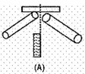  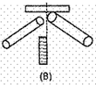  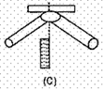  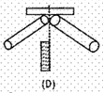  a) D  b) C  c) A  d) B | [1]
18 | In the curve figure, half the wavelength is 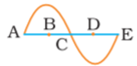  a) A E  b) B D  c) A B  d) D E | [1]
19 | The separation between T and C in the figure given is 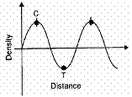  a) $\frac{λ}{2}$  b) $λ$  c) $4λ$  d) $2λ$ | [1]
20 | The pitch of the two signals A and B shown below are P$​_{A}$ and P $​_{B}$ respectively. Then 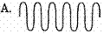  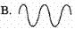  a) P$​_{A}$ > P $​_{B}$  b) P$​_{A}$ < P $​_{B}$  c) P$​_{A}$ = 2P $​_{B}$  d) P$​_{A}$ = P $​_{B}$ | [1]
21 | While doing experiment on verifying the law of reflection of sound, four students measured the angles i and r as shown in the diagram below. The correct measurement of the angle of incidence and angle of reflection has been done by student 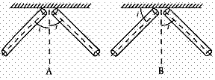  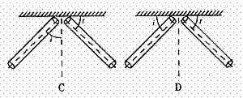  a) B  b) A  c) C  d) D | [1]
22 | By which phenomena of sound bats search their prey at night? 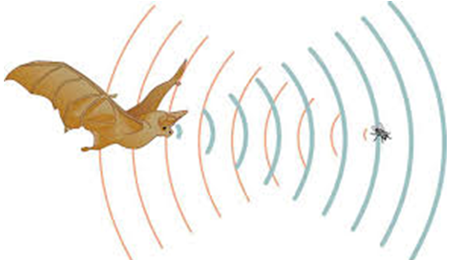  a) Echolocation  b) Reverberation  c) Reflection of sound  d) Multiple reflection | [1]
23 | If the pulse hits at the fixed and as shown in the diagram A. Immediately reflected pulse is: 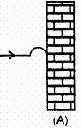  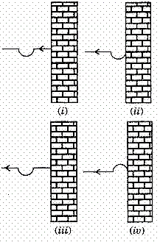  a) (iv)  b) (ii)  c) (iii)  d) (i) | [1]
24 | A student has to choose from the following ’tubes’ and ’plates’ for doing the experiment on verifying the laws of reflection of sound : 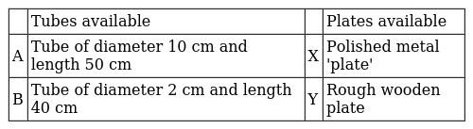  The best choice, for her, is to ’combination’ :  a) B, Y  b) B, X  c) A, Y  d) A, X | [1]
 | Section D
25 | Statement A: Porpoises use ultrasound for navigation and location of food in dark Statement B: When you listen to music or watch TV at home, the noise level is 100 - 120 decibels. Which of the two statements is true?  a) Neither Aor B  b) Statement A  c) Both A and B  d) Statement B | [1]
26 | Statement A: Speeds greater than the speed of sound in the air are called infrasonic speed. Statement B: The amount of sound energy, passing each second through unit area is called intensity of sound. Which of the above two statements is true?  a) Both A and B  b) Statement A  c) Statement B  d) Neither A nor B. | [1]
27 | Statement A: Human beings are ultrasound deaf Statement B: Ultrasonic waves can travel easily in solid, liquid, and gases. Which of the two statements is true?  a) Statement A  b) Both Aand B  c) Statement B  d) None of the two | [1]
28 | Statement A: Molecules also move from one place to another in a wave motion. Statement B: Electromagnetic waves don’t need a material medium to travel. Which of the two statements is/are true?  a) Statement B  b) Neither Aor B  c) Both A and B  d) Statement A | [1]
29 | Statement A: An object moving at a speed greater than that of a sound is moving at ultrasonic speed. Statement B : In wave motion, only energy is transferred. Which of the two statements is true?  a) Statement B  b) Both Aand B  c) Statement A  d) Neither Aor B | [1]
30 | Statement A: Sound travels faster in summer season than in winter season Statement B: The speed of sound does not depend on the pressure of the medium. If the temperature of the medium remains constant Which of the two statements is true?  a) Neither A nor B  b) Statement B  c) Statement A  d) Both A and B | [1]
31 | Statement A: Speed of sound is same at different temperatureStatement B: Loudness is measured in decibels. Which of the two statements is true?  a) Both Aand B  b) Neither statement A norstatement B  c) Statement B  d) Statement A | [1]
 | Section E
32 | Find the incorrect statement  - Sound waves are electromagnetic waves.  - You can’t talk on moon.  - Speed of sound is different at different temp.  - Shock waves are used to break up kidney stone and gall stones without surgery.  a) C  b) D  c) B  d) A | [1]
33 | Which of the following is incorrect?  - Unit of frequency is hertz  - Unit of wavelength is m/s  - Unit of velocity is m/s$​^{2}$  - Unit of the time period is second  a) B and C  b) All of these  c) A and C  d) B and D | [1]
34 | Find the incorrect statement.  - The speed of the wave doesn’t depend on properties of the medium.  - Ultrasound is produced by electronic oscillator.  - 120dB means intensity is 1 W/m$​^{2}$ .  - The distance between crest and trough is$\frac{λ}{2}$ .  a) (D)  b) (A)  c) (B)  d) (C) | [1]
35 | Which of the following statement is true?  - The frequency of man’s voice more than that of woman’s voice.  - Repeated claps of thunder in quick succession are called rolling of thunder.  - Timbre is a typical feature of a sound which enables us to distinguish between the sounds of same loudness and pitch.  a) Both statement (B) and (C)  b) Only statement (B)  c) Only statement (C)  d) Only statement (A) | [1]
36 | Which of the following is incorrect -  a) Aand Bare incorrect  b) A, Band Care incorrect  c) Band Care incorrect  d) All of these | [1]
37 | The correct statement in the following is:  - Sound waves are longitudinal and light waves are transverse  - Sound waves and light waves are both longitudinal waves  - Sound waves are transverse and light waves are longitudinal  - Both sound waves and light waves are transverse  a) (B)  b) (A)  c) (C)  d) (D) | [1]

